project management Plan

for

Car Purchasing WEB App

V 1.1

VERSION HISTORY

|  |  |  |  |  |  |
| --- | --- | --- | --- | --- | --- |
| **Version** | **Implemented By** | **Revision Date** | **Approved By** | **Approval Date** | **Reason** |
| **1.0** | **Beshoy Sameh**  **Aml Mostafa** | **20/02/2023** | **Menna abdelmjeed**  **Salma gamal** | **21/02/2023** | **Initial Version** |
| **1.1** | **Beshoy Sameh** | **23/2/2023** | **Aml Mostafa** | **23/2/2023** | **Added RTM** |
|  |  |  |  |  |  |
|  |  |  |  |  |  |
|  |  |  |  |  |  |
|  |  |  |  |  |  |
|  |  |  |  |  |  |
|  |  |  |  |  |  |

Contents

1. Introduction 3

1.1 Goal 3

1.2 Purpose of project management plan 3

1.3 Timeline 3

I. Team 3

**1.4** **Assumptions and Constraints** 3

I. Assumptions: 3

II. Constraints: 4

**1.5** **Scope Management** 4

I. In Scope: 4

II. Out of Scope: 4

1.6 Work Breakdown Structure 5

I. Diagram 5

2. Schedule / Time Management 6

2.1 Milestones 6

2.2 Project Schedule 6

2.3 Project Life Cycle 7

3. Configuration Management 7

4. Verification and Validation Strategy 8

5. Communication Management 8

I. Communication goals: 8

II. Stockholders' communication: 8

5.1 Communication Matrix 9

6. Risk Management 9

7. REVIEW PROCESS 10

7.1 Procedures 10

8. BASELINE STRATEGY 10

8.1 Workflow for creating new Baseline. 10

8.2 Workflow for recommending Baseline. 10

APPENDIX A: REFERENCES 11

APPENDIX B:  KEY TERMS 11

# Introduction

## Goal

Develop a website to help the user to buy their car from an enormous data.

## Purpose of project management plan

All project stakeholders, including the project sponsor, senior leadership, and the project team, are the target audience for the car purchasing PMP.

## Timeline

We plan to provide Five milestones for the project and define the project as ready for publishing within 5 weeks. (5 Engineers each work daily for 2 hours)

### Team

Our team consists of 5 members as follow:

1. Aml Mostafa
2. Beshoy Sameh
3. Menna Abdelmjeed
4. Salam Gamal
5. Ahmed Fouda

## **Assumptions and Constraints**

### Assumptions:

* Search engine includes searching by Car brand and price.
* A button for adding cars is added to enable sellers to market and submit info about the cars they want to sell.
* Admin can approve and decline car addition, deletion and reservation.

### Constraints:

* Should use Web based System.
* Should obtain Unique user IDs
* Admin features.

## **Scope Management**

### In Scope:

* The scope of this project includes design, implementation and testing of the features described in the succeeding sections of this document.
* Acceptance testing.
* Functional testing & external interfaces.

### Out of Scope:

* Non-functional testing like stress, performance
* Unit and automation testing
* Integration testing
* Payment method

## Work Breakdown Structure

## Diagram

# Schedule / Time Management

## Milestones

* First Release.
* Week One. (Project Kick-off)

|  |  |
| --- | --- |
| **Milestones** | **Estimated Completion Timeframe** |
| Sample in Question (SIQ) | 2/18/2023 |
| Configuration Management Tool setup | 2/20/2023 |
| Project Management Plan (PMP) | 2/21/2023 |
| Software Requirements Specification (SRS) | 2/22/2023 |
| Project Schedule | 2/23/2023 |
| Configuration item list (CIL) | 2/23/2023 |

## Project Schedule

## Project Life Cycle

We are following the Waterfall Model of SDLC

(But we are also using some Agile methodologies in reviewing and daily meetings)

Each step depends on the previous step (Finish to Start)

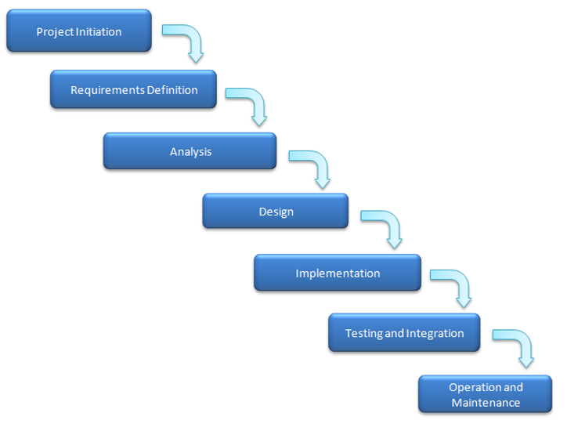

# Configuration Management

We tailored our Configuration Management tool to use GitHub

The guidelines on how we will use the CM:

|  |  |
| --- | --- |
|  |  |

* Pull requests are required for the master branch only.

* Folder Structure:

Readme File is provided to help identifying the location of each file in the below Link:

<https://github.com/beshoysamehsamaan/Car-Purchasing-App>

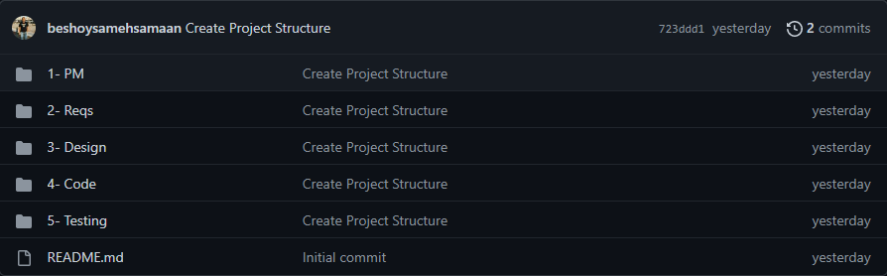

# Verification and Validation Strategy

* 1. **Test Type**

Manual Testing

* 1. **Test levels**

System Test

Acceptance Test

* 1. **Test Techniques**

Black Box

Functional

# Communication Management

**Communication plan**

### Communication goals:

* keep the stakeholder up to date on all new developments and project requirements
* Provide a detailed explanation of any decisions or obstacles that must be made.
* Establish opportunities for stakeholders to provide feedback.

### Stockholders' communication:

* In addition to meetings, whether they be online or offline, we will use formal emails to communicate and explain some points in order to get their feedback on the work and determine whether they would want to make any adjustments or suggest any ideas.

**Project Teams' communication:**

* We are going to use formal mails to communicate and clarify some points related to tools update,

in addition to the daily stand up meetings whether it's an online or face-to-face so as that we can discuss all what we ‘ll do and track our progress.

Also, we can use some social media apps as what's app or Trello for easier and faster communication

## Communication Matrix

|  |  |  |  |  |
| --- | --- | --- | --- | --- |
| Communication Type | Objectives | Medium | Frequency | Audience |
| Project Team Meeting | Discuss the work progress | * Conference call * Face-to-face | Daily | -Whole team |
| Customer Meeting | Clarifying some information  Providing the customer with some information | * Conference call * Emails * Face-to-face | As Needed | - Project manager  - Customer |
| Technical Design Meetings | Discuss and develop technical design solutions for the project. | * Conference call * Face-to-face | As Needed | - Project Technical  - Staff |
| Project Status Reports | Report the status of the project including activities, progress, and issue. | * Emails | Weekly | - Project manager  - Project Team  - Customer |

# Risk Management

External Risk Management File in the below Link:

# REVIEW PROCESS

We maintain that every work product is well reviewed by the right team members through well-defined procedures

## Procedures

1-Assigning the right team members (asking for review on GITHUB).  
2-Providing work product under review.  
3-Supporting reviewers with checklist (it can be a previous similar work product).  
4-Reviewers start review and communicate results (push comments on GITHUB on sub branch ).  
5- Any changes must be approved first then push on the Main branch on GITHUB.

# BASELINE STRATEGY

As a role of project manager, he assigns which version of work products to be worked on by the whole team.

## 8.1 Workflow for creating new Baseline.

1- Lock the integration or parent stream to prevent developers from delivering work while creating the baseline. Developers can continue to work on activities in their development streams.

2- Verify the stability of the project.

3- Make the baseline.

4- Unlock the integration or parent stream so that developers can deliver work.

## 8.2 Workflow for recommending Baseline.

1-Developers rebase their development streams to the recommended baselines.  
 2-The rebase operation updates their work areas with the new baseline

# APPENDIX A: REFERENCES

The following table summarizes the documents referenced in this document.

|  |  |  |
| --- | --- | --- |
| **Document Name** | **Description** | **Location** |
| Change Management Plan | Describe [change control](https://www.stakeholdermap.com/project-dictionary/project-dictionary-c.html#change-control) policies and procedures and how [change control](https://www.stakeholdermap.com/project-dictionary/project-dictionary-c.html#change-control) will interface with other aspects of [project management](https://www.stakeholdermap.com/project-dictionary/project-dictionary-p.html#project-management-pm). |  |
| External Project Schedule File | Describe the roadmap of the project |  |
| External Quality Management File | Identifying the quality requirements and standards for the project and product. |  |
| External Risk Management File | Contain Probable Risk with risk Impact and Probability of Occurrence |  |
| External Issue Management File | Identifying track and resolve project issues throughout the life of the project ensuring effective communication |  |

# APPENDIX B:  KEY TERMS

The following table provides definitions for terms relevant to this document.

|  |  |
| --- | --- |
| **Term** | **Definition** |
| Communication | The effective sending and receiving of information. Ideally, the information received should match the information sent. It is the responsibility of the sender to ensure this takes place. |
| Stakeholder | Individuals or groups involved in the project or whose interests may be affected by the project’s execution or outcome. |
| Communications Management Plan | Portion of the overall Project Management Plan which details how project communications will be conducted, who will participate in communications, frequency of communications, and methods of communications. |
| SDLC | Software Development Life Cycle. |